Database Design Using ERDs
Community Event Planning and Management System

Samita Tamang
Department of Computer Science, Monroe University
25SP-CS700-151HY - Special Projects in Computer Science I
Professor Oluwole Omole-Ohonsi
July 5, 2025

Community Event Planning and Management System
ER-Diagram
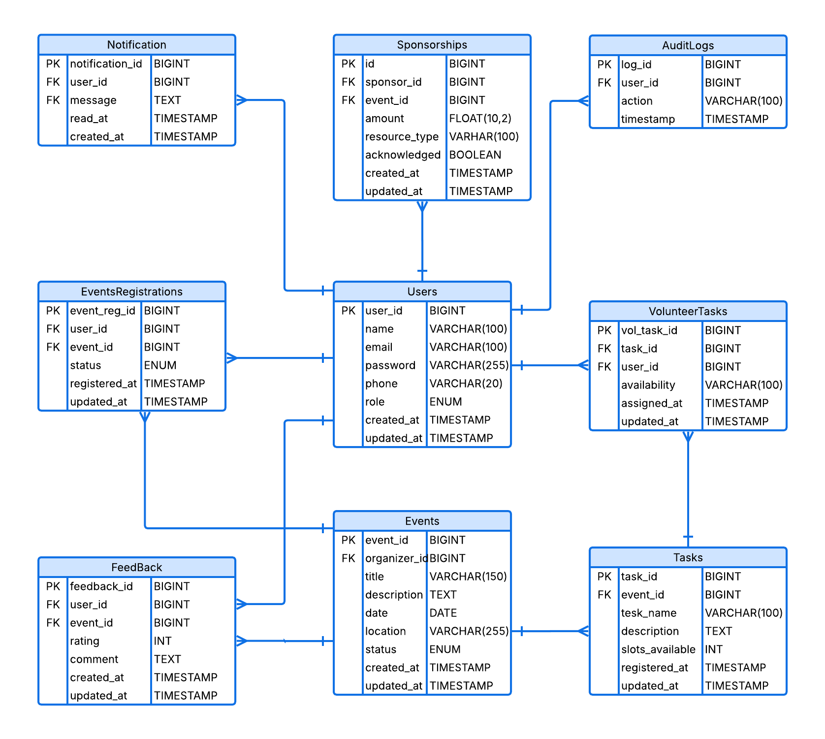
1. Users Table: Stores general info for all user roles. Role determines access rights.
Column Name | Data Type | Key | Description
id | BIGINT | PK | Unique ID for each user
name | VARCHAR(100) |  | Full name of the user
email | VARCHAR(100) | UNIQUE | User’s email address (login)
password | VARCHAR(255) |  | Encrypted password
phone | VARCHAR(20) | NULLABLE | Contact number
role | ENUM |  | user / organizer / volunteer / admin / sponsor
created_at | TIMESTAMP |  | Timestamp of account creation

2. Events Table: Stores all information about community events created by organizers.
Column Name | Data Type | Key | Description
id | BIGINT | PK | Unique event ID
organizer_id | BIGINT | FK → users(id) | Reference to the user who created the event
title | VARCHAR(150) |  | Event title
description | TEXT |  | Detailed description
date | DATE |  | Scheduled date
location | VARCHAR(255) |  | Venue or event location
status | ENUM |  | pending / approved / canceled
created_at | TIMESTAMP |  | Creation timestamp

3. Event_Registrations: Tracks community members registering to participate in events.
Column Name | Data Type | Key | Description
id | BIGINT | PK | Unique registration ID
user_id | BIGINT | FK → users(id) | User registering
event_id | BIGINT | FK → events(id) | Registered event
status | ENUM |  | confirmed / canceled / attended
registered_at | TIMESTAMP |  | Registration time

4. Volunteer_Tasks Table: Stores the task types/slots available for volunteers per event
Column Name | Data Type | Key | Description
id | BIGINT | PK | Unique task ID
event_id | BIGINT | FK → events(id) | Related event
task_name | VARCHAR(100) |  | Name or title of the task
description | TEXT | NULLABLE | Task details
slots_available | INT |  | Number of volunteer slots

5. Volunteer_Assignments Table: Tracks volunteers assigned to specific event tasks.
Column Name | Data Type | Key | Description
id | BIGINT | PK | Unique assignment ID
user_id | BIGINT | FK → users(id) | Volunteer assigned
task_id | BIGINT | FK → volunteer_tasks(id) | Assigned task
availability | VARCHAR(100) | NULLABLE | Time slots available
assigned_at | TIMESTAMP |  | Assignment date

6. Feedback Table: Captures ratings and reviews of events from community members.
Column Name | Data Type | Key | Description
id | BIGINT | PK | Unique feedback ID
user_id | BIGINT | FK → users(id) | User who submitted feedback
event_id | BIGINT | FK → events(id) | Event the feedback is for
rating | INT |  | Rating score (e.g., 1-5)
comments | TEXT | NULLABLE | Additional feedback
submitted_at | TIMESTAMP |  | Feedback time

7. Sponsorships Table
Description: Manages sponsor contributions and tracks which event they supported.
Column Name | Data Type | Key | Description
id | BIGINT | PK | Sponsorship record ID
sponsor_id | BIGINT | FK → users(id) | The sponsor user
event_id | BIGINT | FK → events(id) | Sponsored event
amount | DECIMAL(10,2) |  | Sponsorship amount
resource_type | VARCHAR(100) | NULLABLE | Type of resource (cash, food, etc.)
acknowledged | BOOLEAN |  | Whether sponsor was acknowledged
created_at | TIMESTAMP |  | Date of sponsorship

8. Notifications Table
Description: System-generated updates sent to users about events, tasks, etc.
Column Name | Data Type | Key | Description
id | BIGINT | PK | Notification ID
user_id | BIGINT | FK → users(id) | Recipient of the notification
message | TEXT |  | Notification message
read_status | BOOLEAN |  | Whether it’s been read
created_at | TIMESTAMP |  | Time of creation

9. Audit_Logs Table
Description: Tracks key actions across the system for admin visibility and security.
Column Name | Data Type | Key | Description
id | BIGINT | PK | Log entry ID
user_id | BIGINT | FK → users(id) | Who performed the action
action | VARCHAR(150) |  | Description of the action
timestamp | TIMESTAMP |  | When the action was performed
Summary of Relationships
Relationship | Type
One user → Many events | One-to-Many
One event → Many registrations | One-to-Many
One event → Many tasks | One-to-Many
One task → Many volunteer assignments | One-to-Many
One event → Many feedback entries | One-to-Many
One sponsor → Many sponsorships | One-to-Many
One user → Many notifications | One-to-Many
One user → Many audit logs | One-to-Many

General System Business Rules
- User roles must be clearly defined: Each user must have one and only one role (user, organizer, volunteer, admin, sponsor). The role dictates access permissions throughout the system.
- User emails must be unique: No two users can share the same email address.
- Passwords must be securely encrypted: Passwords must be hashed before storage, not stored as plain text.
- Timestamps are automatically captured: created_at, submitted_at, and other datetime fields should auto-fill during record creation for traceability.

Events
- Only users with the organizer role can create events.
- All new events must start with a pending status and require admin approval to become approved.
- An organizer cannot schedule two events at the exact same time and location (enforce unique constraint or logic).
- Canceled events must not accept new registrations or feedback.
- Events can only have feedback submitted by registered attendees after the event date has passed.

Event Registrations
- Only users with role user can register for events.
- Each user can register only once per event.
- User registrations cannot be updated once the event has occurred.
- Registration status must only be one of: confirmed, canceled, or attended.

Volunteering
- Only users with the volunteer role can sign up for volunteer tasks.
- A volunteer can be assigned to only one task per event, unless stated otherwise.
- Volunteer assignments cannot exceed the slots_available defined per task.
- Volunteers must specify their availability when signing up.
- Task assignment must reference an existing task under the specified event.

Feedback
- Only users who attended an event can submit feedback for it.
- Feedback must include a rating between 1 and 5.
- Each user can give feedback only once per event.
Sponsorships
- Only users with the sponsor role can make sponsorships.
- Sponsorship amount must be greater than zero.
- Each sponsorship must reference an approved event.
- Once a sponsor is acknowledged, this record becomes read-only (no edits allowed).
Notifications
- Only the system (automated processes) can generate notifications.
- Each notification must be linked to a specific user and include a non-empty message.
- Unread notifications should default to read_status = false.
Audit Logs
- All critical actions (like event approval, task assignment, user creation) must be logged.
- Logs must capture the user who performed the action and a timestamp.
- Audit logs are immutable — once created, they cannot be edited or deleted.
Relational Integrity and Foreign Keys
- Deleting a user should either:
- Cascade delete related non-critical data (like feedback, notifications), OR
- Restrict deletion if critical links exist (like sponsorships, created events).
- Every foreign key must reference an existing record — enforce referential integrity.
- On deletion of an event:
- Remove all volunteer assignments, registrations, and feedback
- Retain sponsorships and audit logs for accountability (mark as historical)

